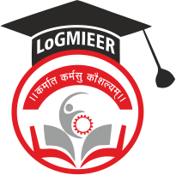
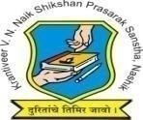
Krantiveer Vasantrao Narayanrao Naik Shikshan Prasarak Sansta’s
Loknete Gopinathji Munde Institute of Engineering Education & Research, Nashik.

Program/Activity Report

Type of Activity | R3 Systems India Private Limited
Name of activity:- | Industrial Visit
Date:- | 17/02/26
Duration:- | 1 Day
Time:- | 11.00 AM
Resource person | Gauresh Surywanshi
Objective of program | To understand the basic concepts of web page designing and develop simple, structured, and responsive web pages using HTML and CSS.  To give students practical exposure to real-world web development processes and  understand how professional websites are designed, developed, tested, and maintained in the industry.
Detail schedule | - Welcome of students  - Company Visit  - To give brief idea about industry and some ideas for latest technologies.  - Feedback from students
No. of participants | 41
Sponsor (if any) | LOGMIEER
Organizing committee | Computer Department

Photos:

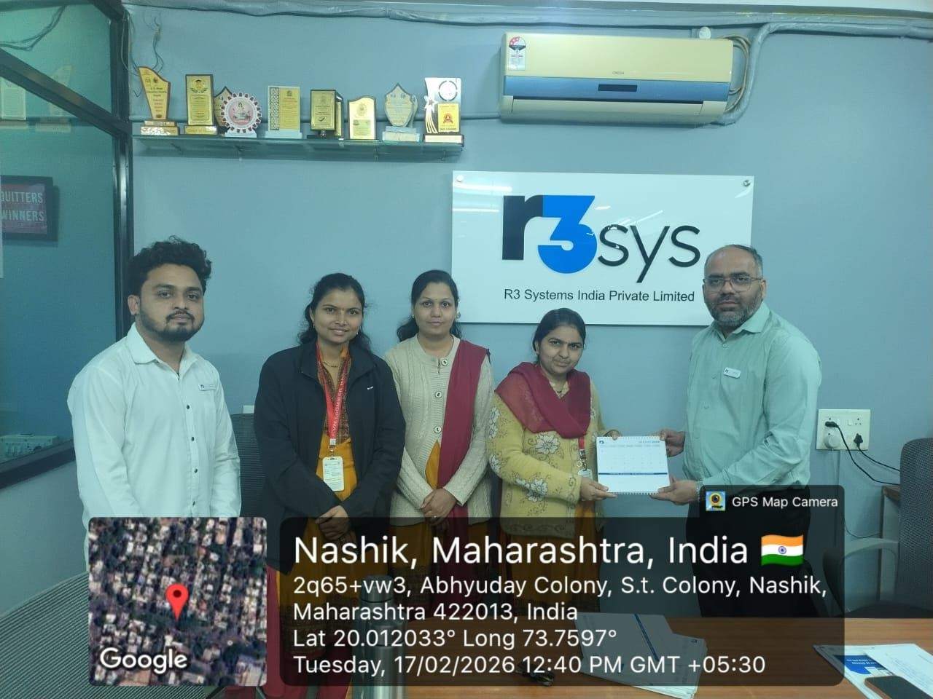
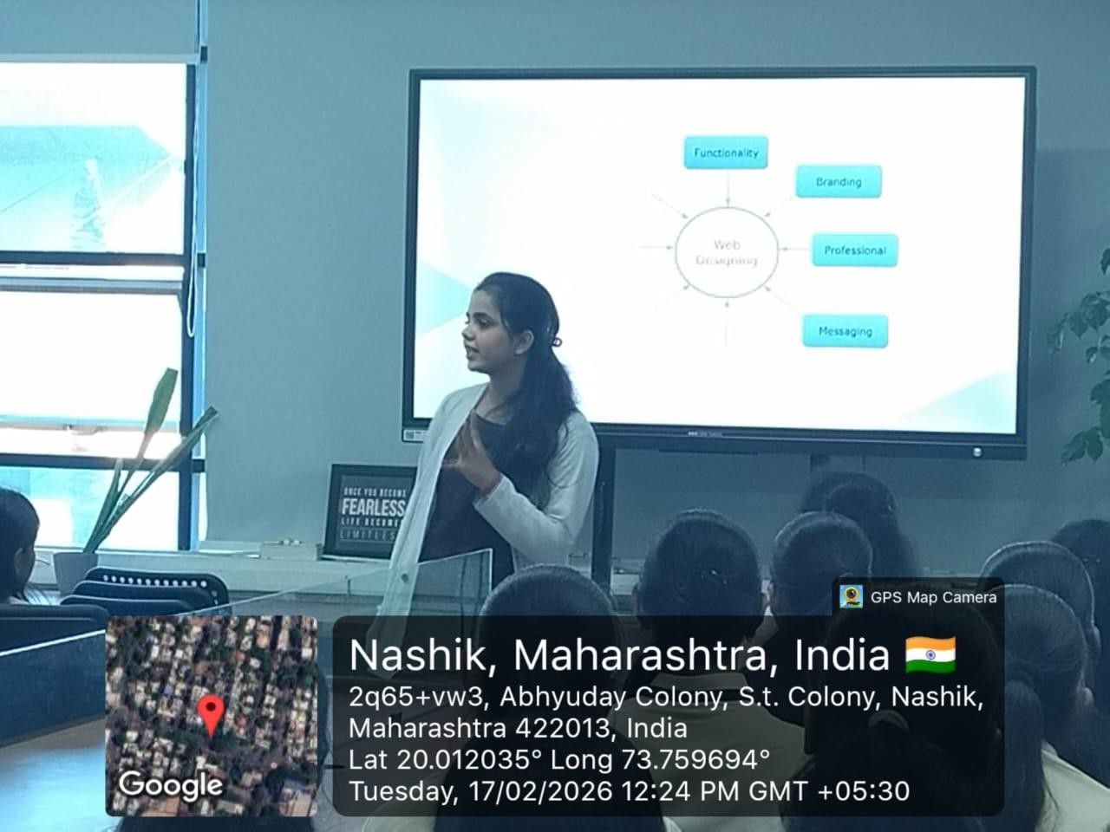

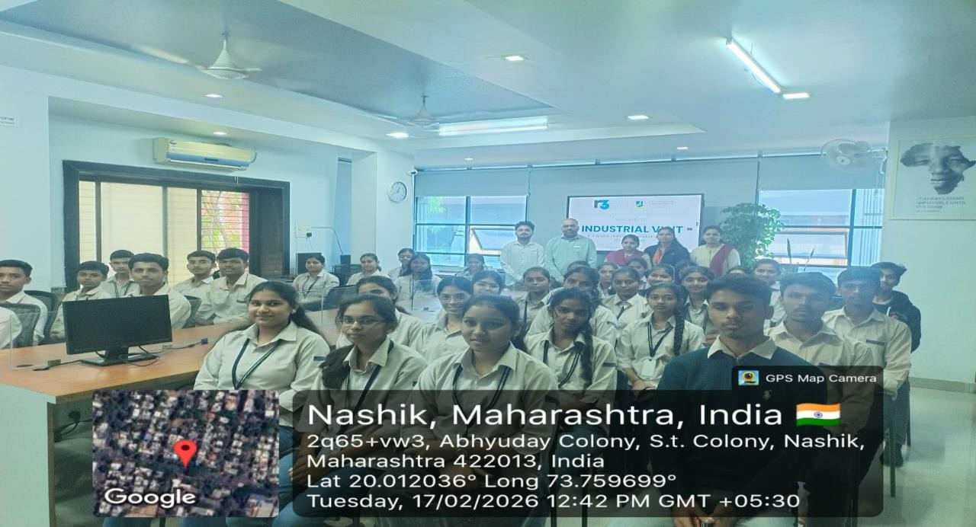

Prof. S. S. Dharbale Prof. V.J.Bodake
( Activity Co-ordinator ) (HOD of Computer Department)

