
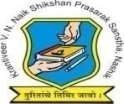
Krantiveer Vasantrao Narayanrao Naik Shikshan Prasarak Sansta’s
Loknete Gopinathji Munde Institute of Engineering Education & Research, Nashik.

Program/Activity Report

Type of Activity | Industrial Visit to Nexonica Systems Pvt Ltd ,Nashik
Name of activity:- | Industrial Visit
Date:- | 10/10/25
Duration:- | 1 Day
Time:- | 10.00 AM
Resource person | Prakash Ekande
Objective of program | To learn about modern technologies such as Artificial Intelligence (AI), Internet of Things (IoT), cloud computing, and web/mobile application development used by the compan
Detail schedule | - Welcome of students  - Company Visit  - give brief idea about Company .  - Feedback from students
No. of participants | 50
Sponsor (if any) | LOGMIEER
Organizing committee | Computer Dept

Photos:

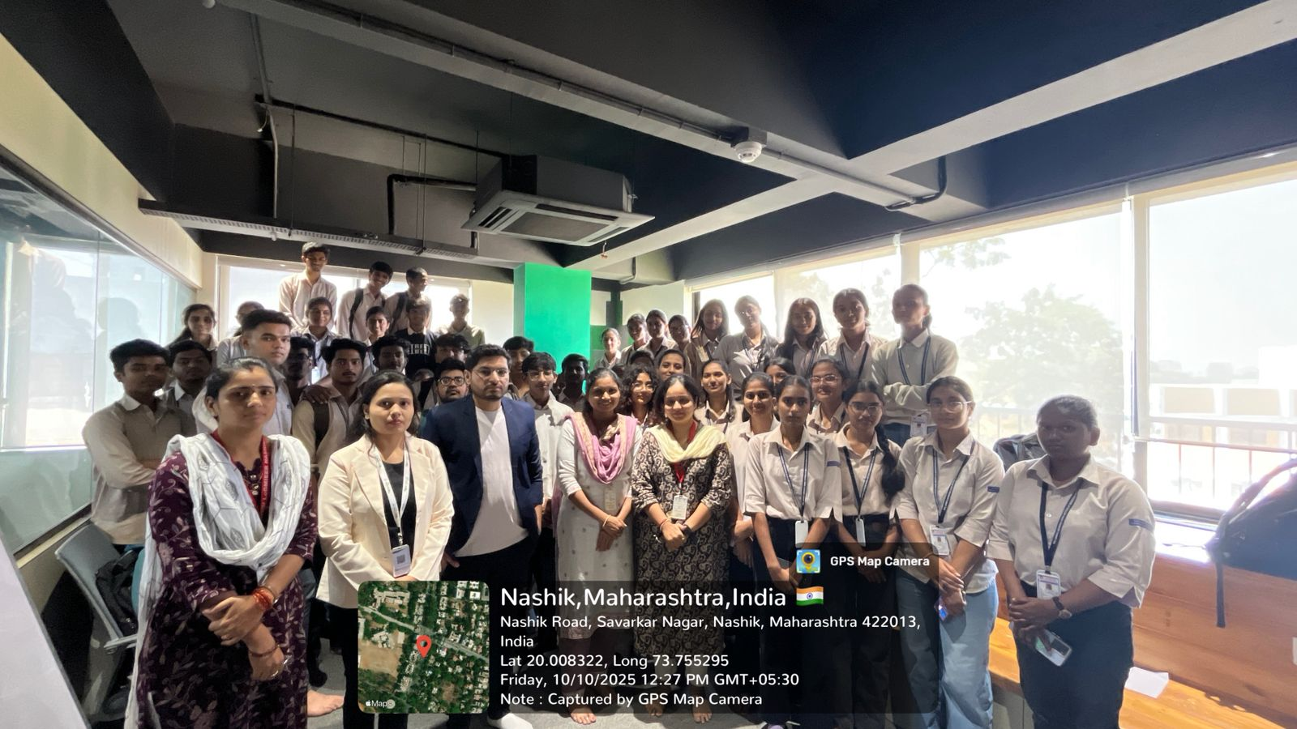
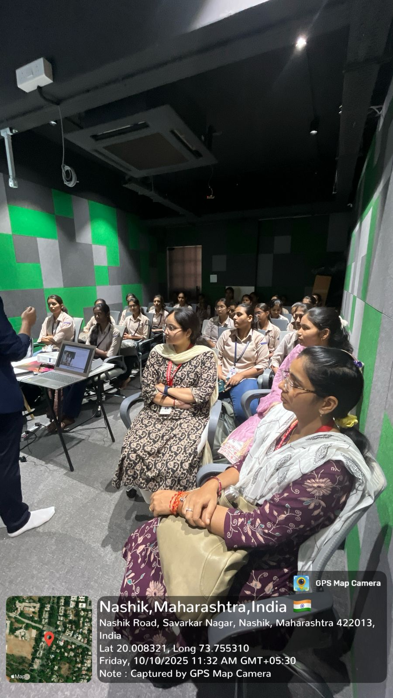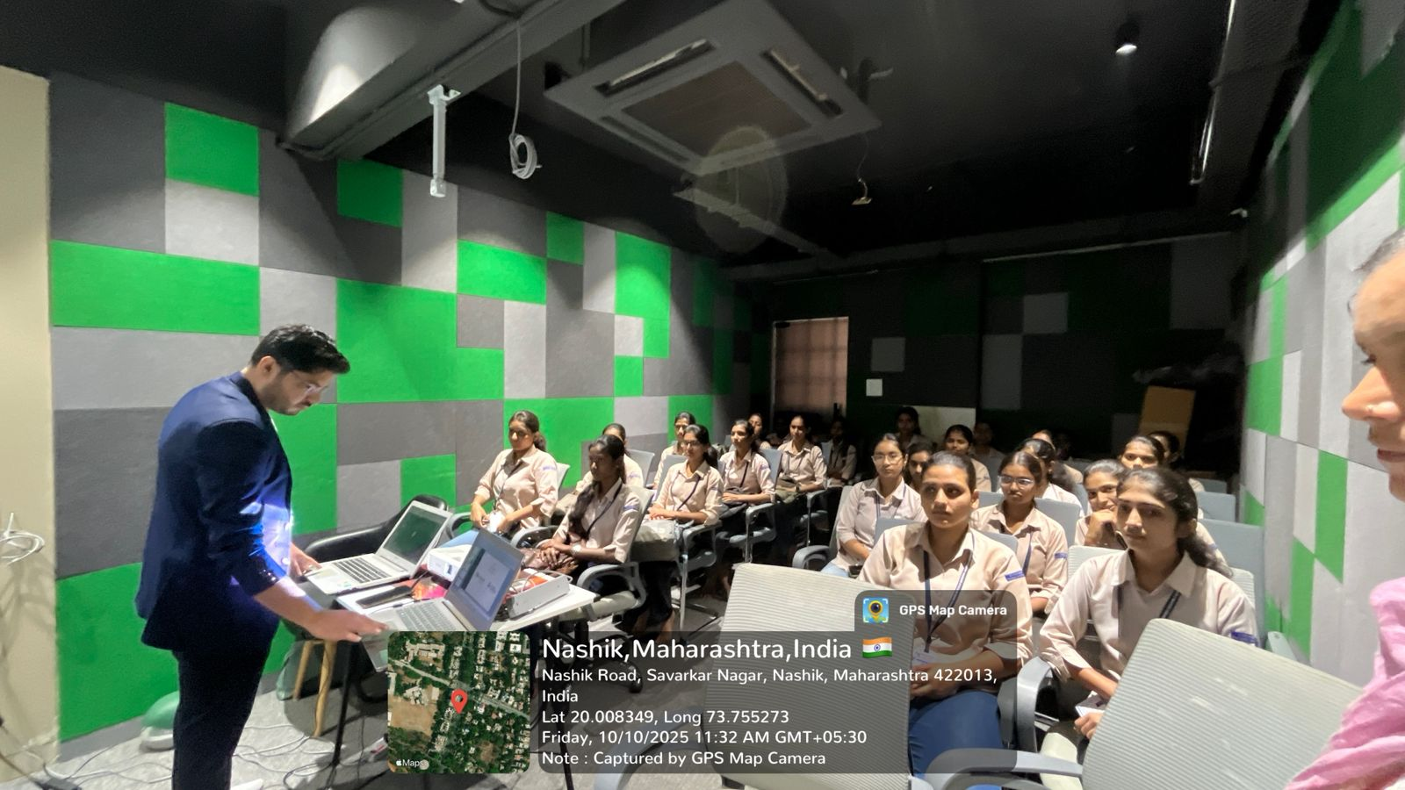

Prof. S. S. Dharbale Prof. V.J.Bodake Visit Co-ordinator (HOD of Computer Department)

