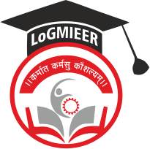
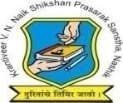
Krantiveer Vasantrao Narayanrao Naik Shikshan Prasarak Sansta’s
Loknete Gopinathji Munde Institute of Engineering Education & Research, Nashik.

Program/Activity Report

Type of Activity | Industrial Visit to NP IT SOLUTIONS – Software Development & Digital Marketing Company,Nashik
Name of activity:- | Industrial Visit
Date:- | 10/10/25
Duration:- | 1 Day
Time:- | 10.00 AM
Resource person | Superintendent Engineer
Objective of program | To give brief idea about water supply plant
Detail schedule | - Welcome of students  - Company Visit  - give brief idea about Company .  - Feedback from students
No. of participants | 60
Sponsor (if any) | LOGMIEER
Organizing committee | Computer Dept

Photos:
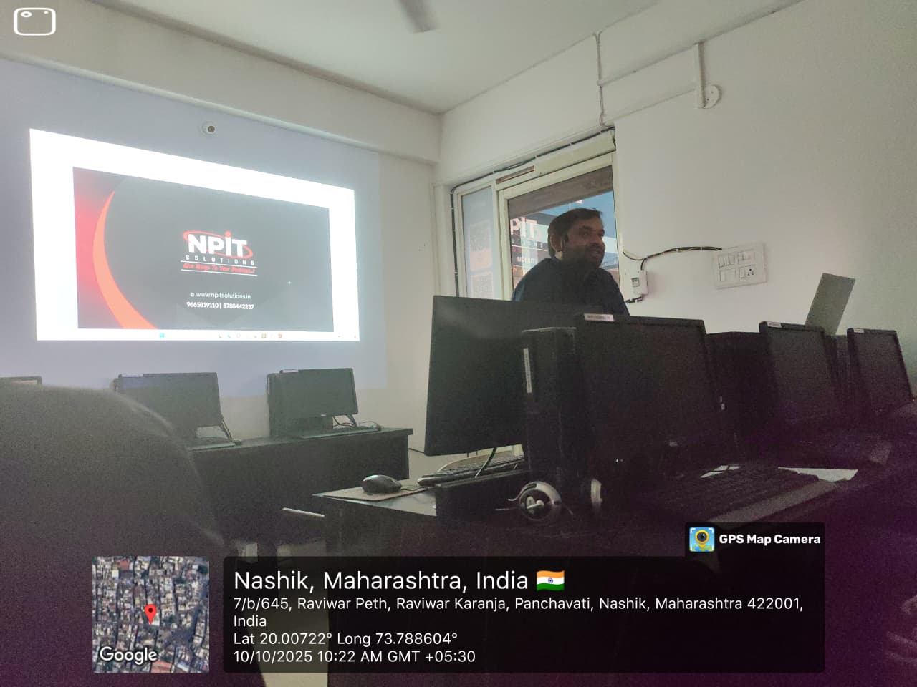

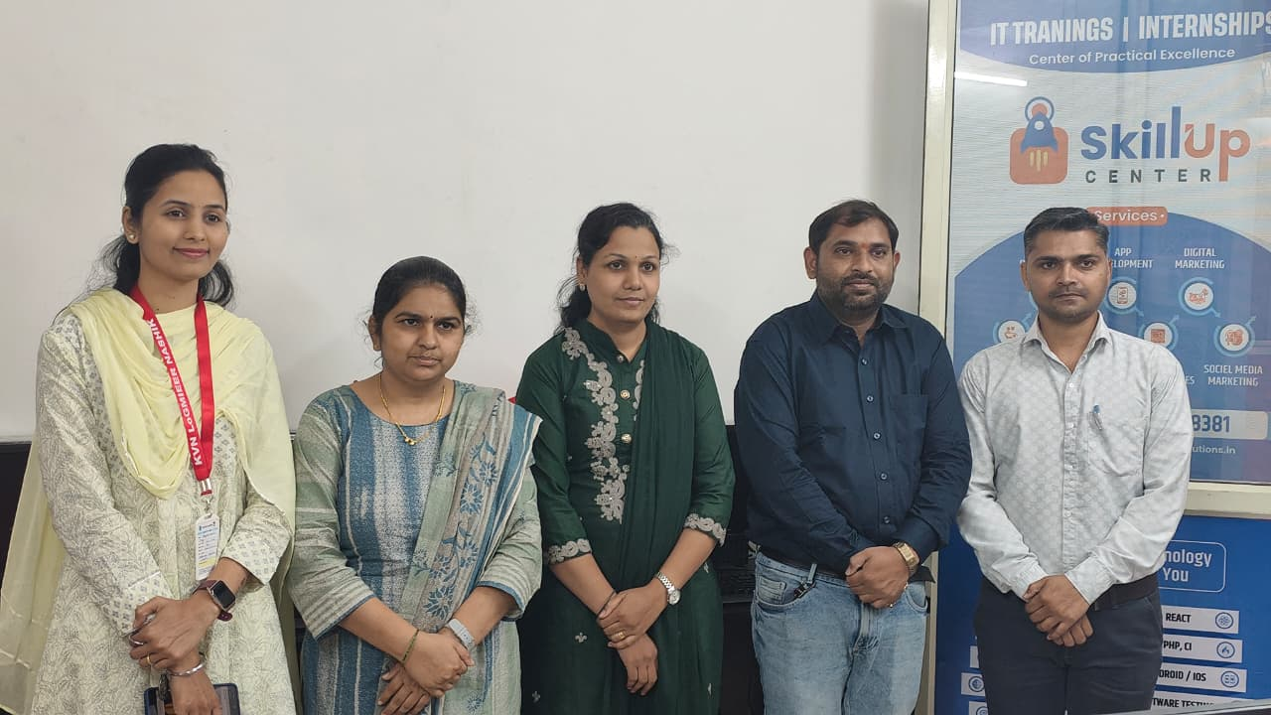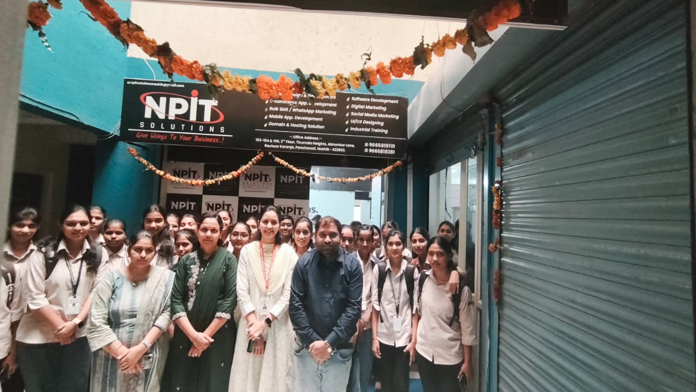

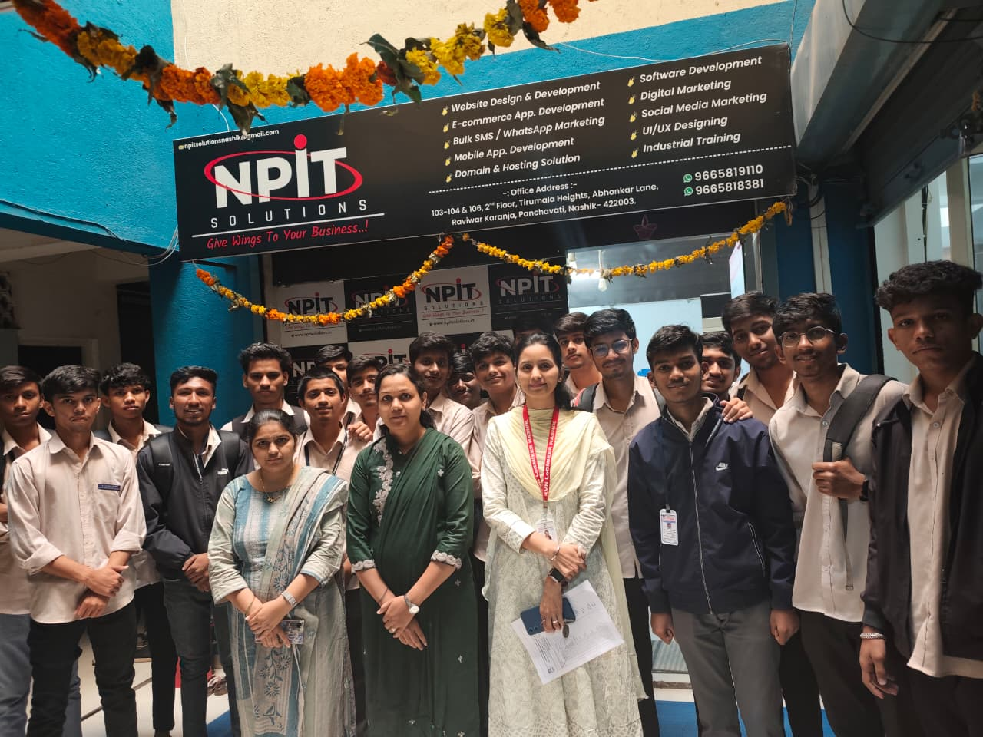

Prof. V.J.Bodake
(HOD of Computer Department)

