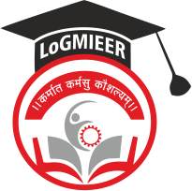
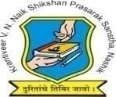
Krantiveer Vasantrao Narayanrao Naik Shikshan Prasarak Sansta’s
Loknete Gopinathji Munde Institute of Engineering Education & Research, Nashik.

Program/Activity Report

Type of Activity | Industrial Visit to Manasvi Tech Solutions,Nashik
Name of activity:- | Industrial Visit
Date:- | 30/01/26
Duration:- | 1 Day
Time:- | 10.30 AM
Resource person | Ms.Monli Gaud
Objective of program | To give brief idea about industry and some ideas for latest technologies
Detail schedule | - Welcome of students  - Company Visit  - To give brief idea about industry and some ideas for latest technologies.  - Feedback from students
No. of participants | 50
Sponsor (if any) | LOGMIEER
Organizing committee | Computer Dept

Photos:
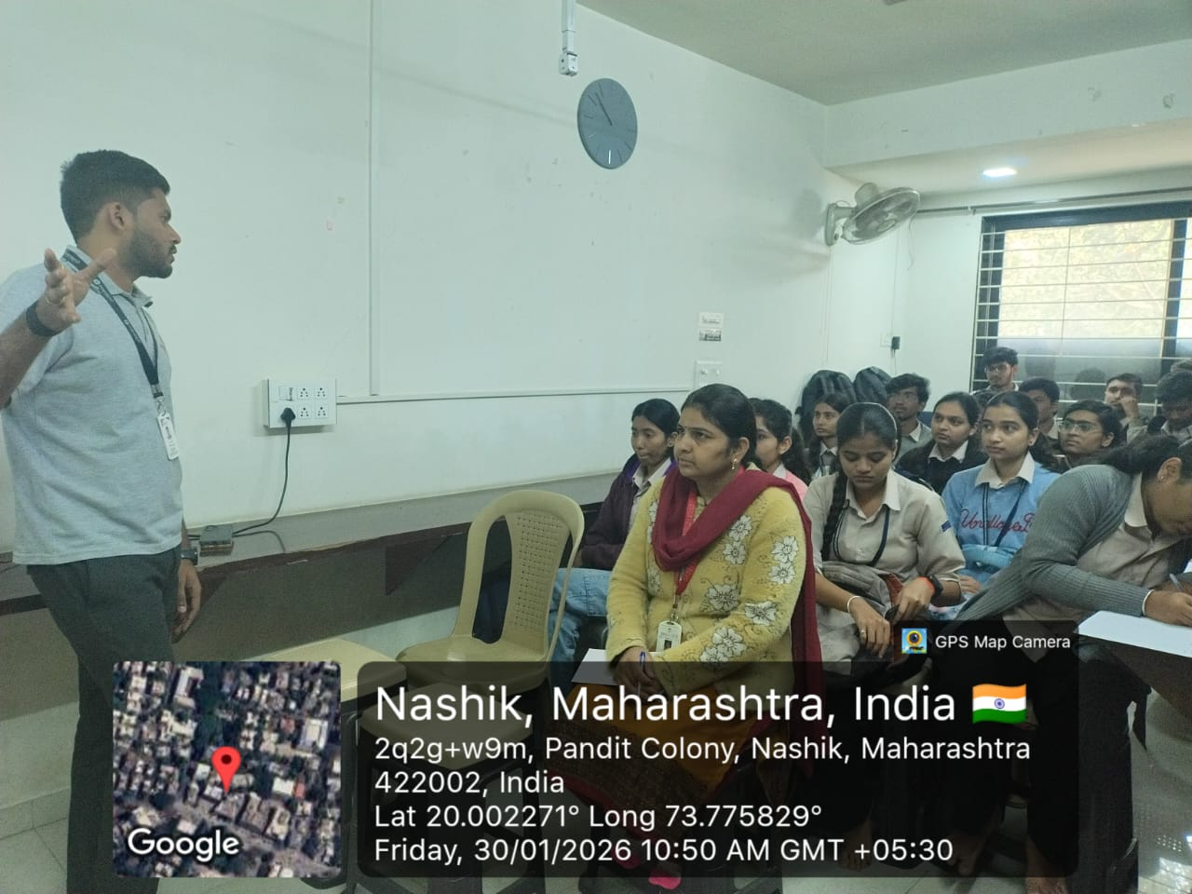
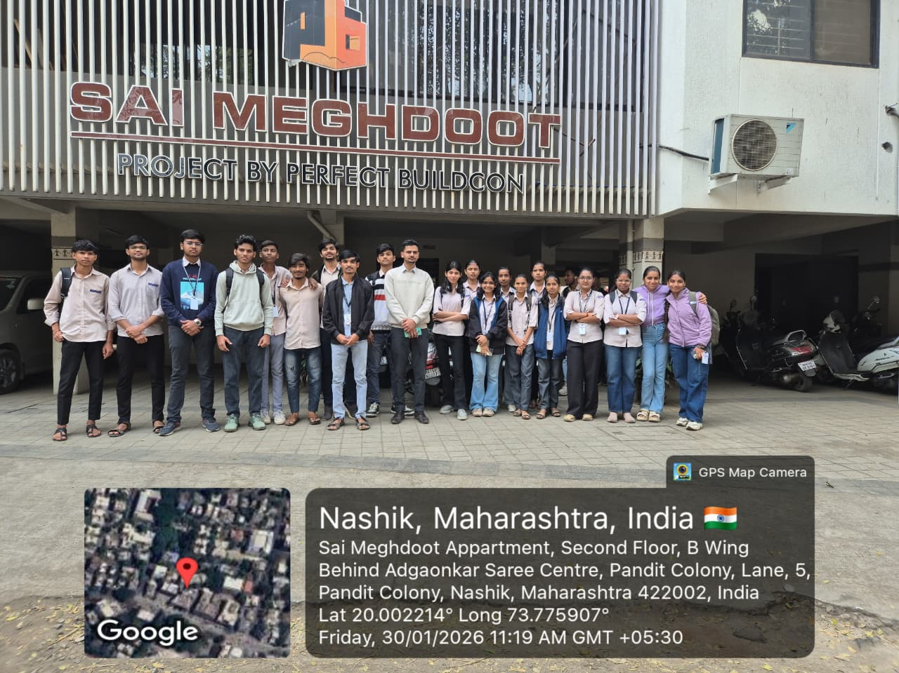
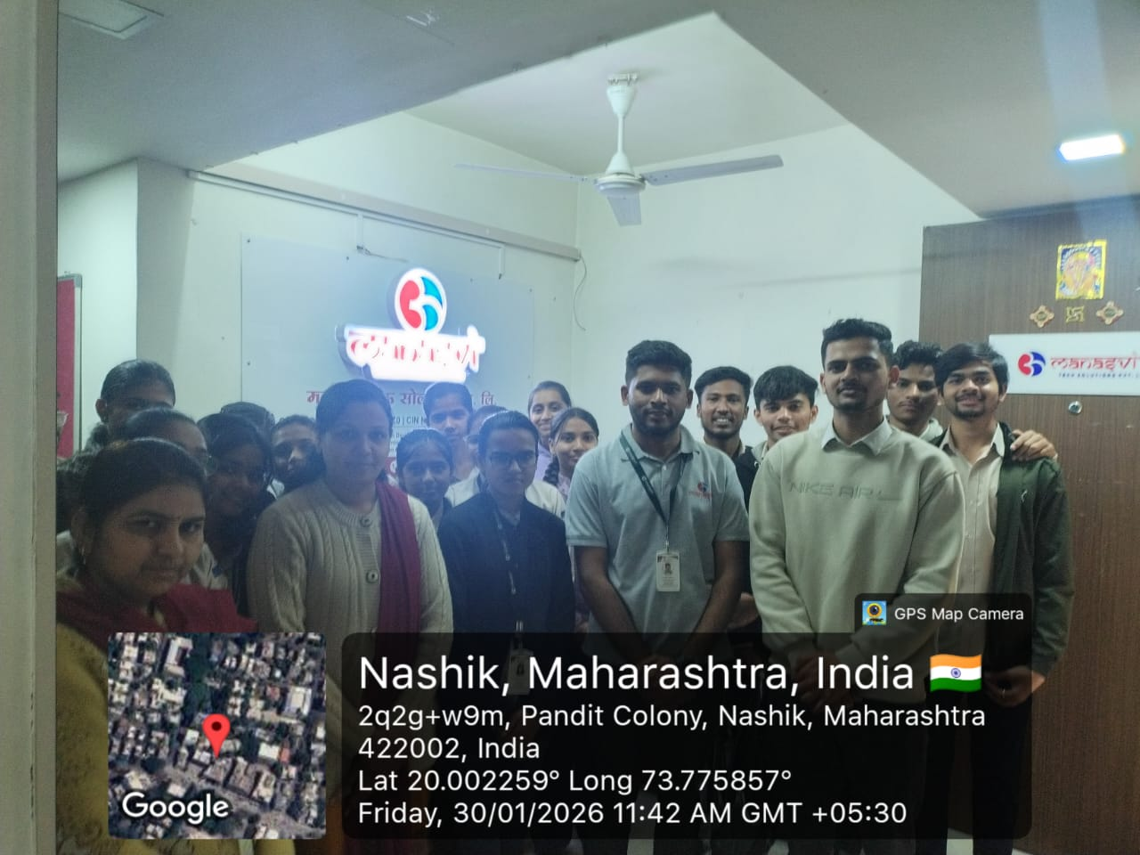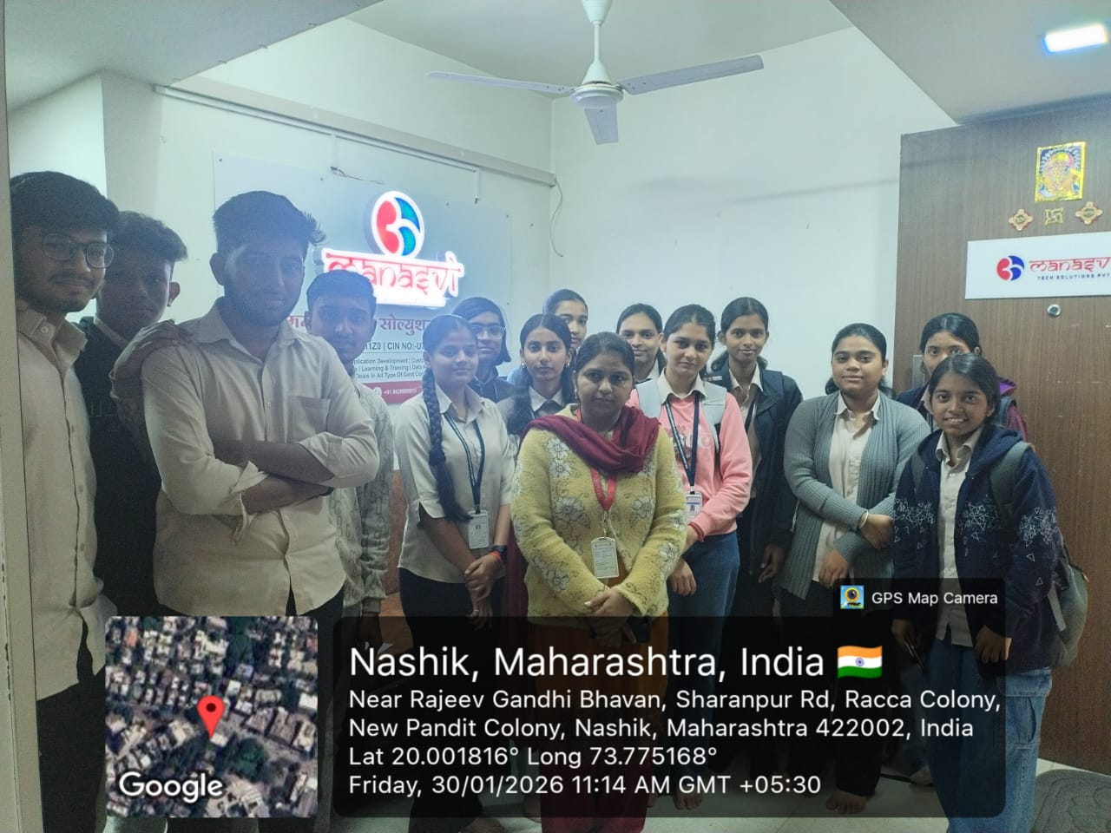

Prof. V.J.Bodake
(HOD of Computer Department)

