
AD-05 | Activity Report | Academic Year: 2025-26
Rev-01 | Activity Report | Semester: III
DEPARTMENT OF COMPUTER ENGINEERING
Particulars | Description
Activity | Expert talk
Activity level | College Level
Title | Essence of Indian Constitution
Speaker / Resource Person  Name  Designation  Organization/Institute Name and address | Mr. Ajit Takke  Secretary, MVPNV Member,  Maharashtra Bamboo Samiti Parishad  Speaker on Topics related to Human Lifestyle and Constitution
Organized by | Computer Department
Venue | Seminar Hall
Date & Time | 24/09/2025 (10.00AM to 12.00PM)
Objectives of the activity | Minimum 1 and Maximum 3
Outcomes of activity | Minimum 1 and Maximum 3
Targeted participants | Second Year students of all the branches
Total no. of participants, Participation % | 120
Content of the activity | Constitution & Preamble  Fundamental Rights & Directive Principles  Governance & Amendments  Electoral Literacy and Voter’s Education
Relevance to POs | PO1, PO2, PO4, PO5, PO7
Relevance to PSOs | No Relevance to PSOs
Methodology used | PowerPoint presentation  Presentation with notes and comments  Discussion.
Brief Description of the Activity | i) The speaker highlighted the significance of the Constitution as the supreme law of the land and explained how the Preamble reflects the guiding principles of justice, liberty, equality, and fraternity.  ii) Participants were made aware of the Fundamental Rights guaranteed to every citizen, ensuring dignity and freedom.  iii) The role of constitutional amendments in adapting to changing socio-political needs was discussed with examples of landmark amendments.  iv) Awareness regarding free, fair, and ethical voting practices was promoted to strengthen democratic institutions.
Geo- tag photos of the Activity | 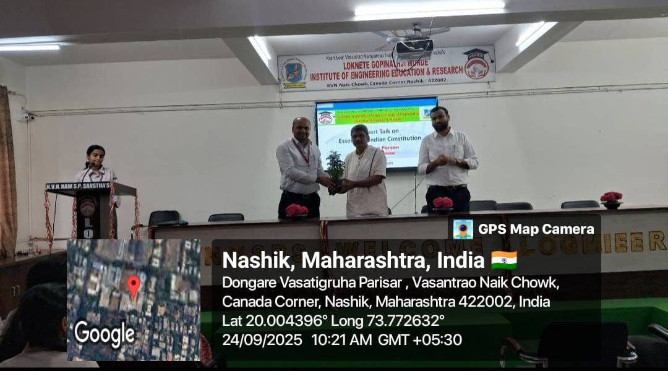  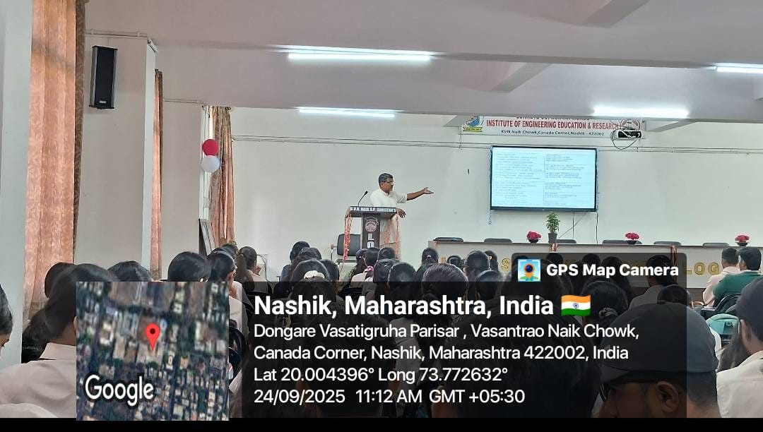
Prof.S.S.Dharabale |  | Prof.V.J.Bodake
Coordinator |  | HOD

