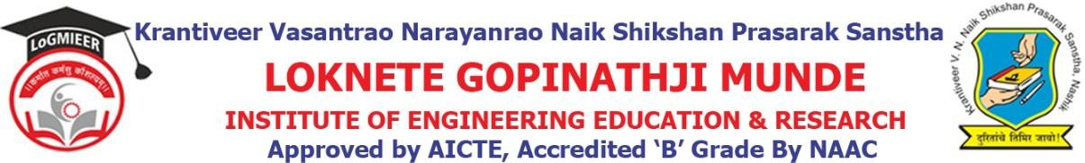

DepartmentofComputerEngineering

Program/ActivityReport

Typeof Activity | ExpertLecture
Nameof activity:- | Expert Lecture on Block chain Technology
Date:- | 24-03-2025
Duration:- | 1Day
Time:- | 10 AM to 12PM
Resource person | Prof.H.P.Bhabad
Objective ofprogram | To provide a secure, transparent, and decentralized system for recording and verifying transactions
Detail schedule | - Introductionabouttheeventgivenbystudent.  - Felicitationof prof.H.P.Bhabad byHODProf.V.J.Bodake.  - Guidance about technology.  - Voteofthanksbystudent.
No. of participants | 70
Sponsor (if any) | LoGMIEER
Organizing committee | - Prof.V.J.Bodake(H.O.DComputer&DiplomaCo-ordinator)  - Prof.K.V.Karad(Lecturer)

