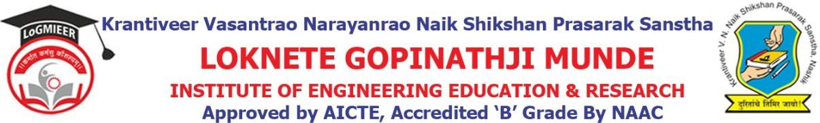

DepartmentofComputerEngineering

Program/ActivityReport

Typeof Activity | Expert Lecture
Nameof activity:- | Expert Lecture on Career Grooming and mastering
Date:- | 14-02-2025
Duration:- | 1Day
Time:- | 12PM
Resource person | Mr. Aditya Salunkhe
Objective ofprogram | To guide students in career grooming and mastering essential professional skills for future success
Detail schedule | - Introduction about the event given by student.  - Felicitationof Mr.aditya salunkhe byHODProf.V.J.Bodake.  - Guidance about technology.  - Vote of thanks by student.
No. of participants | 50
Sponsor (if any) | LoGMIEER
Organizing committee | - Prof.V.J.Bodake(H.O.DComputer&DiplomaCo-ordinator)  - Prof.K.V.Karad(Lecturer)

