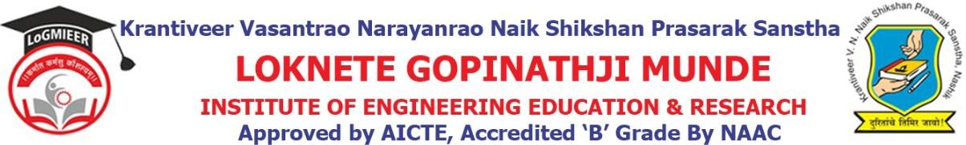

DepartmentofComputerEngineering

Program/ActivityReport

Typeof Activity | Expert Lecture
Nameof activity:- | Expert Lecture on Digital Marketing
Date:- | 7-10-2025
Duration:- | 1Day
Time:- | 1 pm
Resource person | Mr.Nilesh Patil
Objective ofprogram | To make all student aware about digital marketing .
Detail schedule | - Introduction about the event given by student.  - Felicitation of guest by HOD Prof.V.J.Bodake.  - Guidance about digital marketing.  - Vote of thanks by student.
No. of participants | 100
Sponsor (if any) | LoGMIEER
Organizing committee | - Prof.V.J.Bodake(H.O.DComputer&DiplomaCo-ordinator)  - Prof.K.V.Karad(Lecturer)

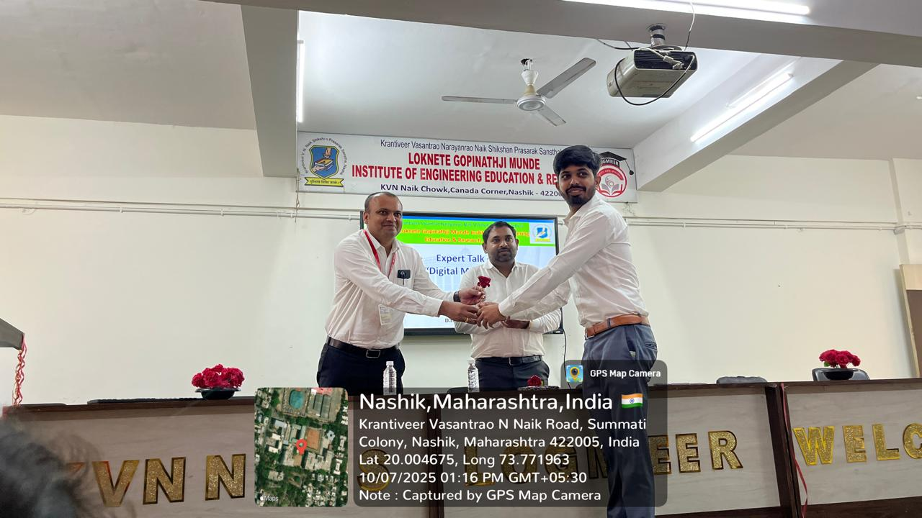

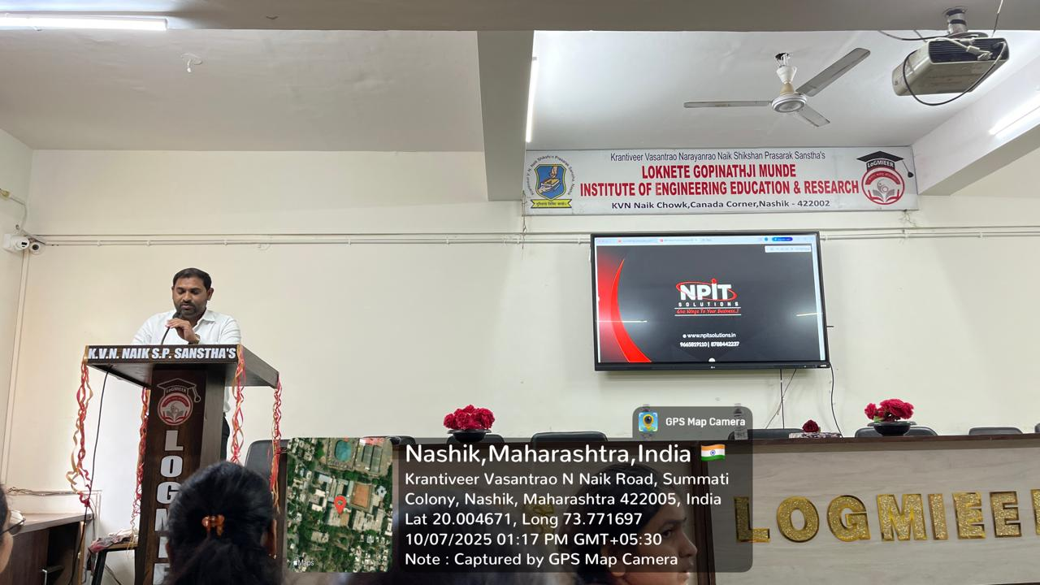

Prof.V.J.Bodake
(HODofComputerDepartment)

