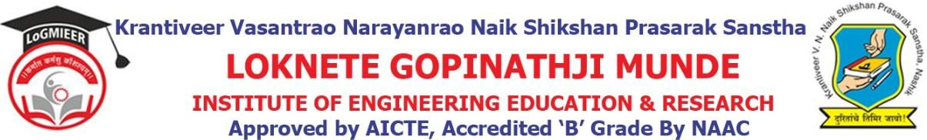

DepartmentofComputerEngineering

Program/ActivityReport

Type of Activity | Expert Lecture
Name of activity:- | Expert Lecture on Machine Learning
Date:- | 8/1/2026
Duration:- | 1Day
Time:- | 10:30 AM to 12.30PM
Resource person | Dr.Vishal Patil
Objective ofprogram | To make all UG students to understand knowledge of machine learning .
Detail schedule | - Introduction about the event given by student.  - Felicitation of guest by HOD Prof. V. J. Bodake.  - Guidance about technology .  - Vote of thanks by student.
No. of participants | 37
Sponsor (if any) | LoGMIEER
Organizing committee | - Prof.V.J.Bodake(H.O.DComputer&DiplomaCo-ordinator)  - Prof.K.V.Karad(Lecturer)

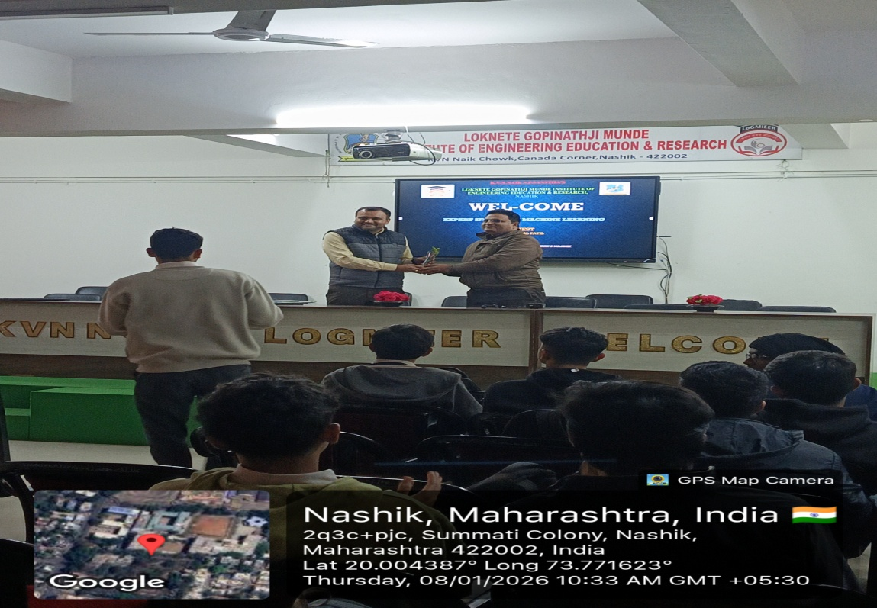

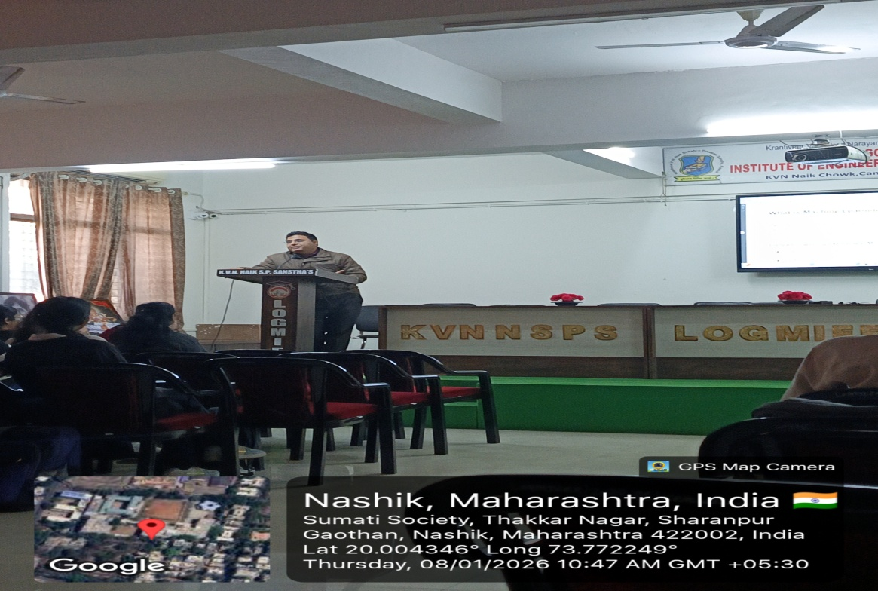

Prof.V.J.Bodake
(HOD of Computer Department)

