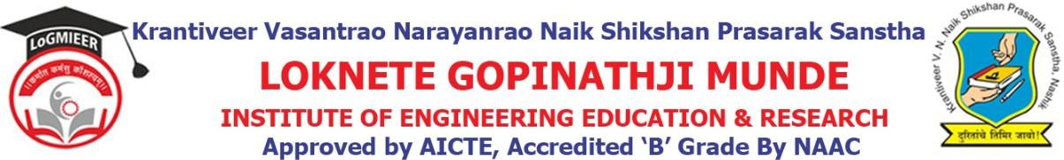

DepartmentofComputerEngineering

Program/ActivityReport

Typeof Activity | Expert Lecture
Nameof activity:- | Expert Lecture on Virtualizations technology
Date:- | 26-10-2024
Duration:- | 1Day
Time:- | 10 AM to 12PM
Resource person | Mr.Ashish Mutrak
Objective ofprogram | To provide touch of virtualization
Detail schedule | - Introductionabouttheeventgivenbystudent.  - Felicitationof guest byHODProf.V.J.Bodake.  - Guidance about technology.  - Voteofthanksbystudent.
No. of participants | 60
Sponsor (if any) | LoGMIEER
Organizing committee | - Prof.V.J.Bodake(H.O.DComputer&DiplomaCo-ordinator)  - Prof.K.V.Karad(Lecturer)

