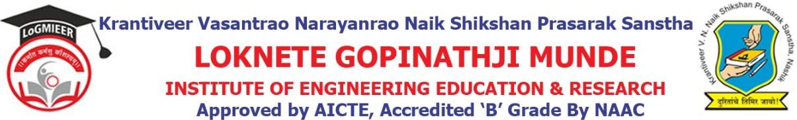

Department of Computer Engineering

Program/Activity Report

Type of Activity | Expert Lecture
Name of activity:- | Expert Lecture on Personal Development
Date:- | 13-3-2026
Duration:- | 1 Day
Time:- | 10 AM to 12 PM
Resource person | Mr. Sanjay Bhadkamkar
Objective of program | To make all UG, student aware about Holistic Approach to Personal Development.  Help individuals understand their strengths, weaknesses, values, and goals.  Build Confidence and Self-Esteem
Detail schedule | - Introduction about the event given by student.  - Felicitation of Mr. Sanjay Bhadkamkar by HOD Prof.V.J.Bodake.  - Guidance about Provide proper direction and support to individuals in making informed decisions about their personal, academic, and career development..  - Vote of thanks by student.
No. of participants | 65
Sponsor (if any) | LoGMIEER
Organizing committee | - Prof. V.J.Bodake (H.O.D Computer & Diploma Co-ordinator)  - Prof. S.V.Deore (Lecturer)

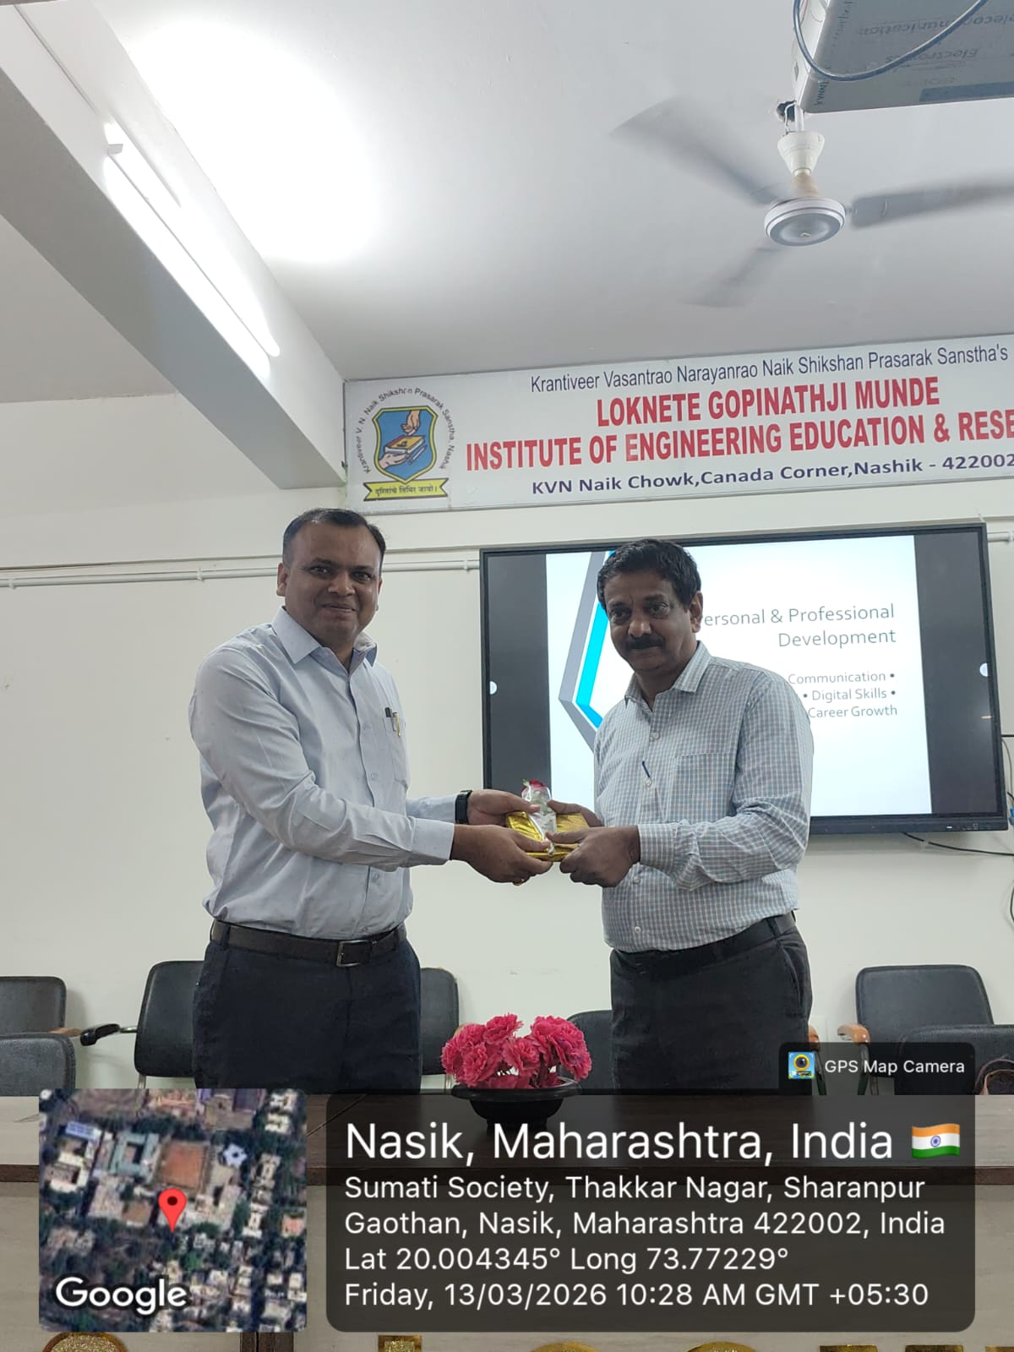

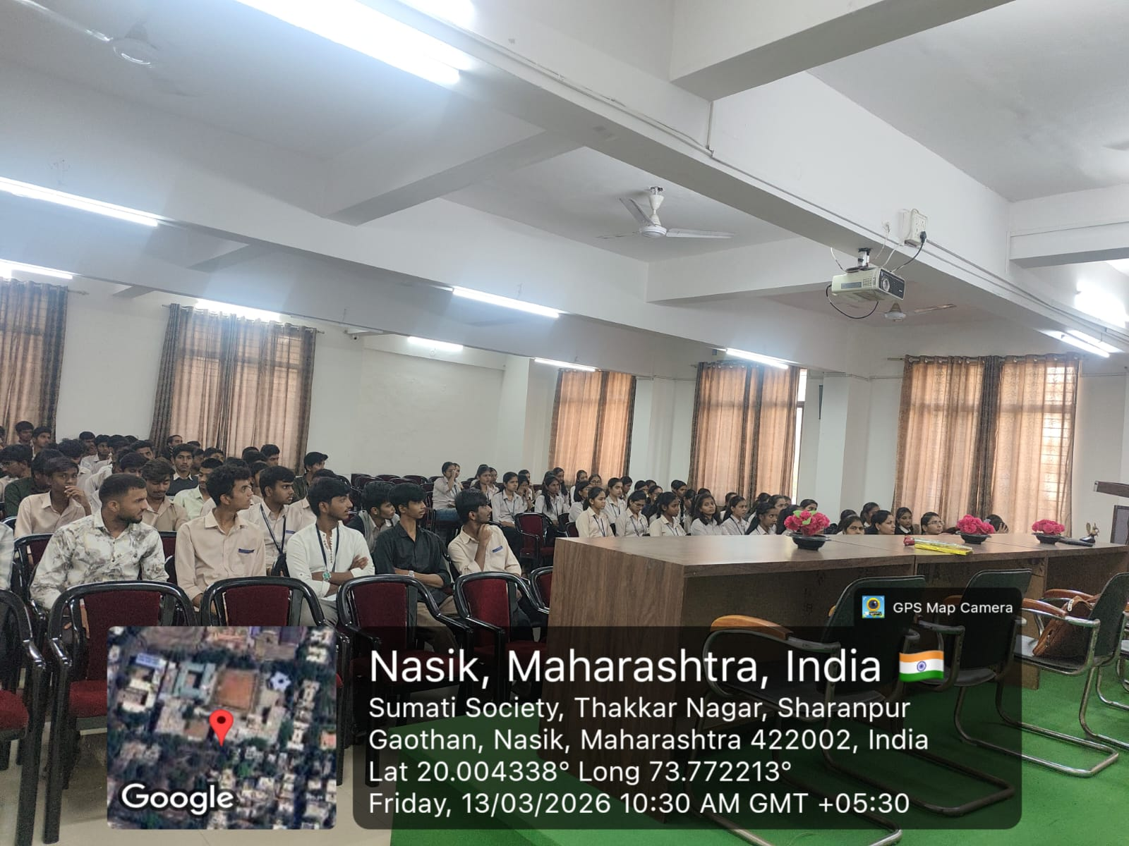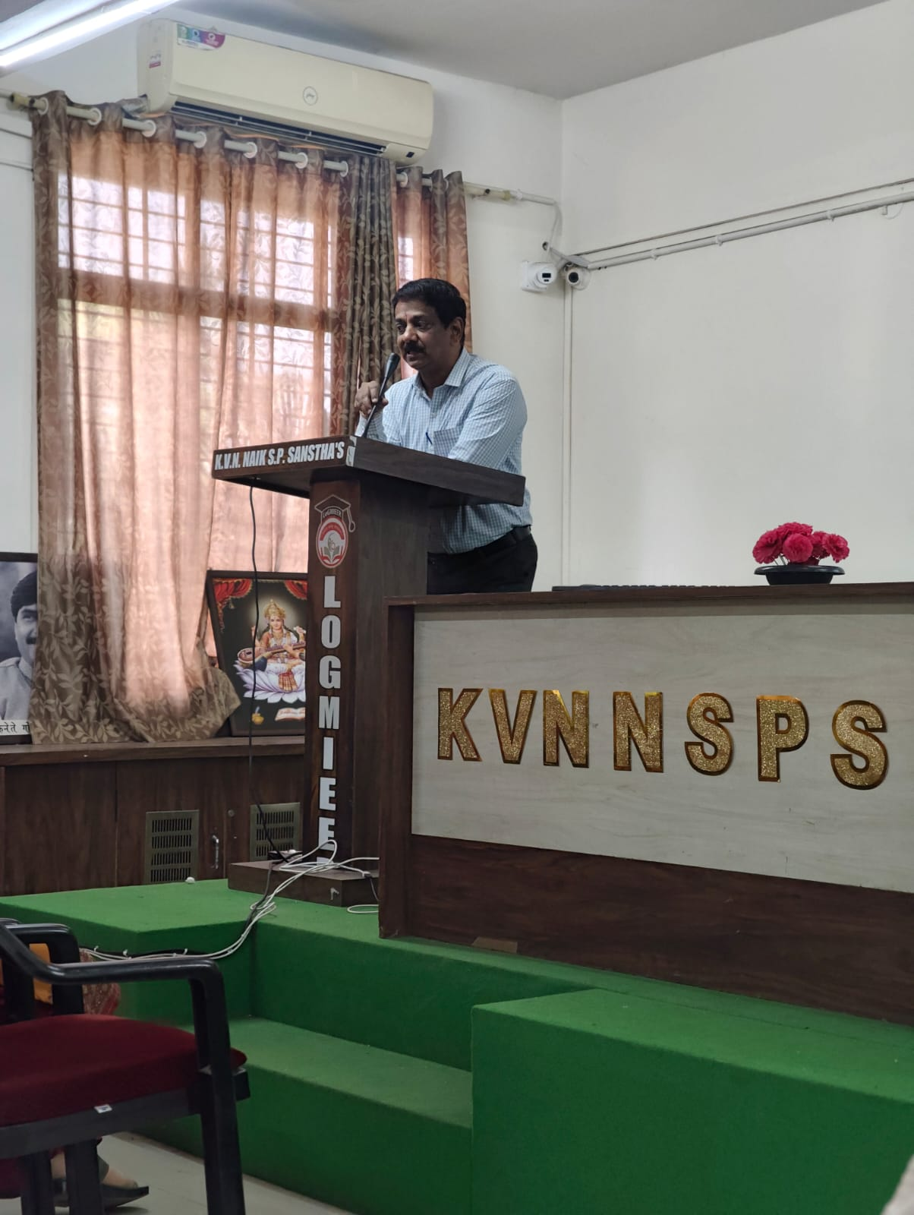

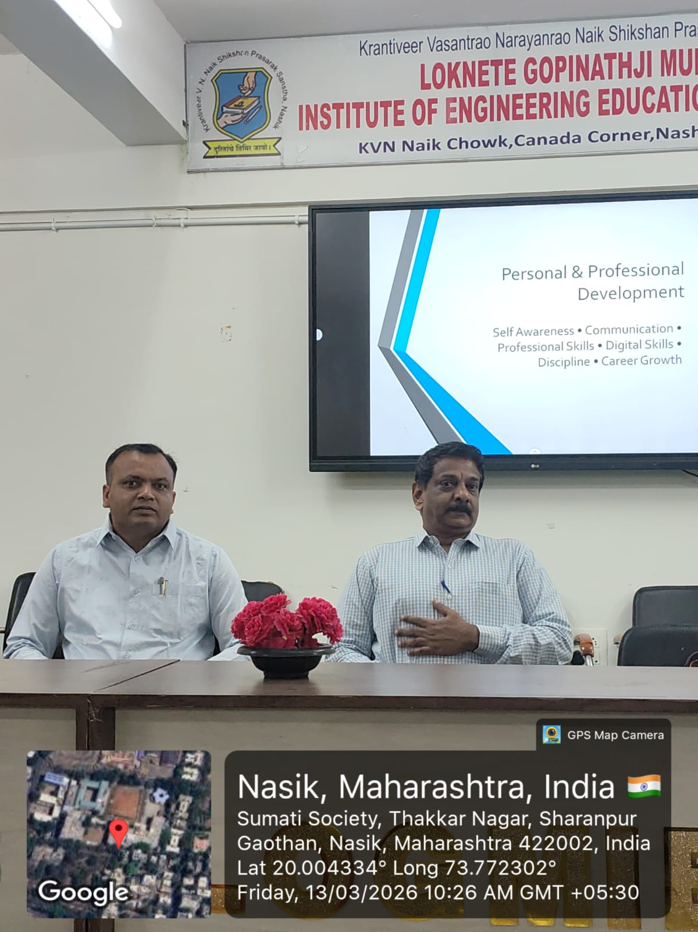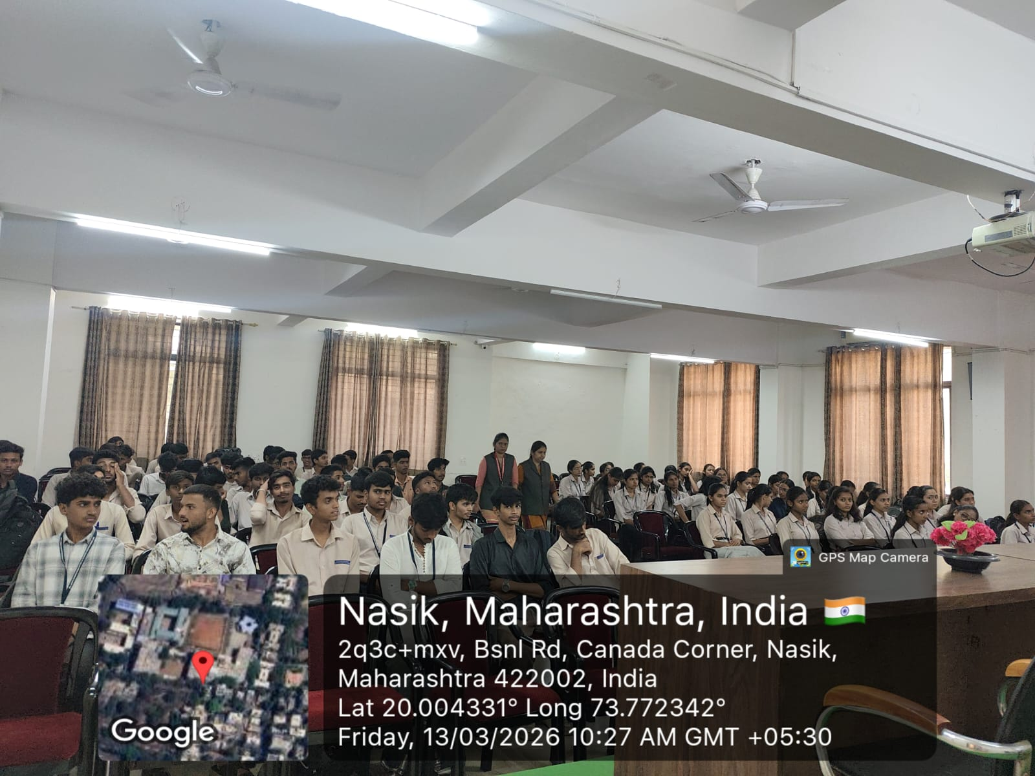

Prof. V.J.Bodake
(HOD of Computer Department)

