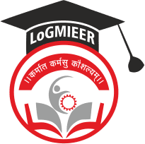
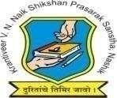
Krantiveer Vasantrao Narayanrao Naik Shikshan Prasarak Sansta’s
Loknete Gopinathji Munde Institute of Engineering Education & Research, Nashik.

Program/Activity Report

Type of Activity | Parents Teachers Meeting
Name of activity:- | PTM
Date:- | 05/09/26
Duration:- | 1 Day
Time:- | 10.30 AM
Resource person | HOD & All Faculty members
Objective of program | To ensure parents and teachers work together for the student's academic, personal, and professional development
Detail schedule | - Registration  - Welcome of Parents & Students.  - Brief idea about the Department  - Ideas on Latest Technologies  - Tea/Refreshment Break  - Individual Interaction with parents  - Feedback from Parents
No. of participants | 50
Sponsor (if any) | LOGMIEER
Organizing committee | Computer Dept

Photos:

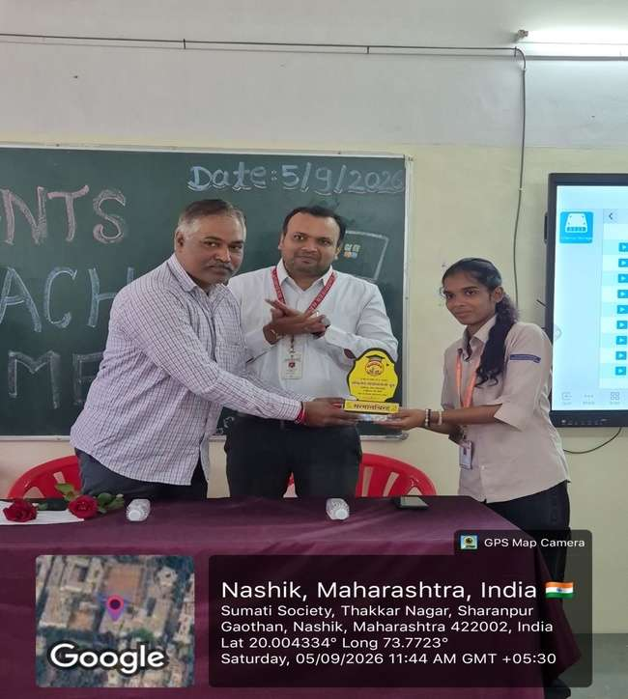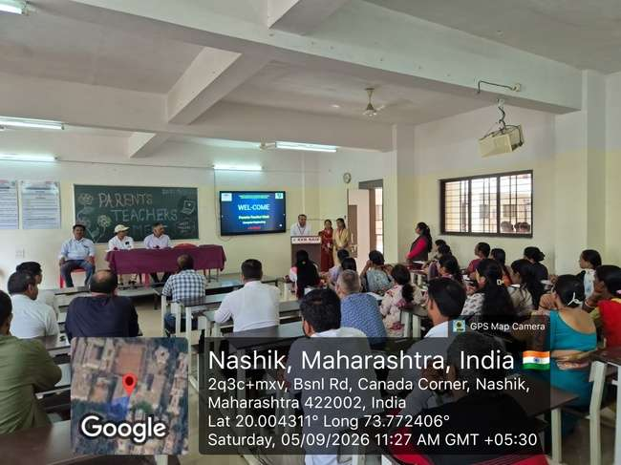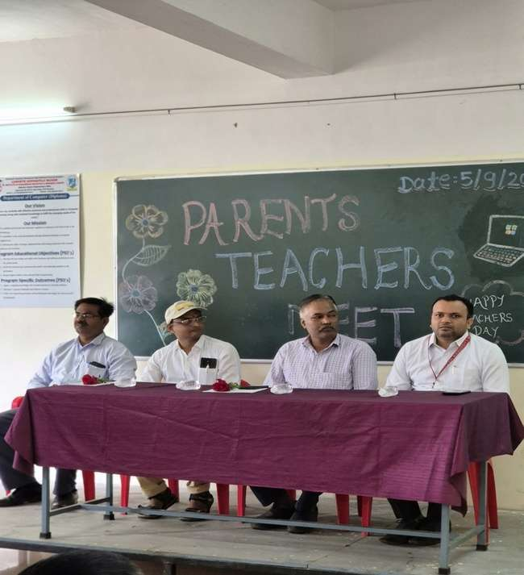

Prof. V.J.Bodake
(HOD of Computer Department)

